***Transfer Learning-Based Classification of Poultry Diseases for Enhanced Health Management***

1. **INTRODUCTION**
   1. *Project Overview:*

Poultry diseases pose a major threat to the health and productivity of livestock, especially in rural areas where timely veterinary support is limited. Early detection is essential for controlling outbreaks, but manual diagnosis is often slow, error-prone, and inaccessible to small-scale farmers. This project proposes an intelligent system that leverages transfer learning to accurately classify poultry diseases from images or symptoms.

* Uses pre-trained deep learning models (e.g., ResNet, VGG) for disease detection.
* Trained on poultry disease image datasets for accurate, real-time classification.
* Delivers diagnostic support through a user-friendly mobile or web interface.
* Aims to assist farmers and vets with automated, accessible health diagnostics.
* Reduces the dependency on expert intervention for initial screening.

By integrating AI with veterinary science, this project offers a scalable, cost-effective solution to monitor poultry health. It enhances disease management, prevents large-scale losses, and supports rural agricultural sustainability through timely intervention and informed decision-making.

* 1. *Purpose:*

The main purpose of this project is to enhance the speed, accessibility, and accuracy of poultry disease diagnosis using transfer learning. By identifying diseases in their early stages, it aims to reduce poultry mortality and improve farm productivity. This AI-powered system empowers farmers and veterinarians with actionable insights and reduces dependency on manual diagnostics.

* Enable early detection of poultry diseases using automated image-based classification.
* Reduce diagnostic delays through AI-driven predictions and symptom analysis.
* Support accessible disease screening for small and large poultry farms alike.

Ultimately, this project seeks to strengthen poultry health management through smart diagnostics, promoting tech adoption in agriculture and improving economic resilience in the farming community

**2. IDEATION PHASE**

***2.1 Problem Statement***

|  |  |
| --- | --- |
| Date | 30 June 2025 |
| Team ID | LTVIP2025TMID35759 |
| Project Name | Transfer Learning-Based Classification of Poultry Diseases for Enhanced Health Management |
| Maximum Marks | 2 Marks |

**Customer Problem Statement:**

Create a problem statement to understand your customer's point of view. The Customer Problem Statement template helps you focus on what matters to create experiences people will love.

The Customer Problem Statement template helps identify challenges from the user’s perspective to build impactful and relevant solutions. For poultry disease classification, understanding farmers’ pain points is critical to designing a tool that is practical, scalable, and beneficial across regions.

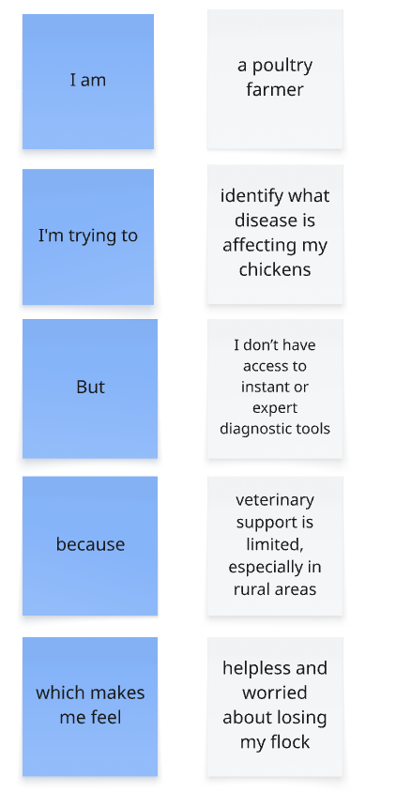

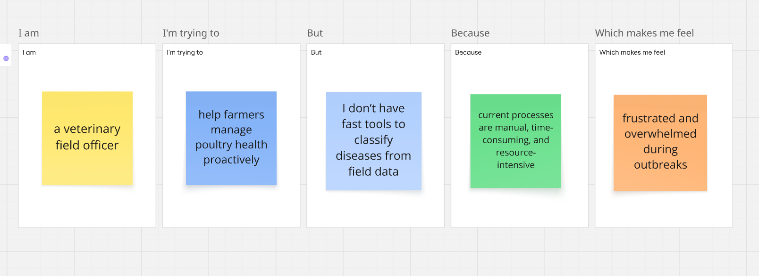**Example:**

|  |  |  |  |  |  |
| --- | --- | --- | --- | --- | --- |
| **Problem Statement (PS)** | **I am (Customer)** | **I’m trying to** | **But** | **Because** | **Which makes me feel** |
| PS-1 | a poultry farmer | identify what disease is affecting my chickens | I don’t have access to instant or expert diagnostic tools | veterinary support is limited, especially in rural areas | helpless and worried about losing my flock |
| PS-2 | a veterinary field officer | help farmers manage poultry health proactively | I don’t have fast tools to classify diseases from field data | current processes are manual, time-consuming, and resource-intensive | frustrated and overwhelmed during outbreaks |

**2. IDEATION PHASE**

***2.2 Empathy Map Canvas***

|  |  |
| --- | --- |
| Date | 30 June 2025 |
| Team ID | LTVIP2025TMID35759 |
| Project Name | Transfer Learning-Based Classification of Poultry Diseases for Enhanced Health Management |
| Maximum Marks | 4 Marks |

**Empathy Map Canvas:**

An empathy map is a simple, easy-to-digest visual that captures knowledge about a user’s behaviours and attitudes. Use this canvas to empathize with your primary users or stakeholders involved in poultry health management. This helps in deeply understanding their needs, pain points, and behavior, especially when applying AI-based solutions like transfer learning.

## 1. Says

• I want a quick way to know if my chickens are sick.

• I cannot afford frequent vet visits.

• I heard about AI but don’t know how it can help me.

## 2. Thinks

• Will this AI solution be easy for me to use?

• Is the app reliable for real-time disease detection?

• Can I trust it more than my experience or local advice?

## 3. Does

• Monitors chickens daily using manual observation.

• Contacts local veterinarian only when outbreak is suspected.

• Maintains basic health records with pen and paper.

## 4. Feels

• Frustrated by slow response to disease outbreaks.

• Anxious about the financial impact of disease spread.

• Hopeful that technology might make life easier.

## 5. Pain

• Late identification of symptoms leads to big losses.

• Technology feels too complex or unaffordable.

• Inconsistent vet availability in remote areas.

## 6. Gain

• Early detection and less bird mortality.

• Easy-to-use tool available on mobile.

• Greater control over farm health.

**Example:**

**2. IDEATION PHASE**

***2.3 Brainstorming***

|  |  |
| --- | --- |
| Date | 30 June 2025 |
| Team ID | LTVIP2025TMID35759 |
| Project Name | Transfer Learning-Based Classification of Poultry Diseases for Enhanced Health Management |
| Maximum Marks | 4 Marks |

**Brainstorm & Idea Prioritization:**

Brainstorming provides a free and open environment that encourages everyone within a team to participate in the creative thinking process that leads to problem solving. Prioritizing volume over value, out-of-the-box ideas are welcome and built upon, and all participants are encouraged to collaborate, helping each other develop a rich amount of creative solutions.

**Step-1: Team Gathering, Collaboration and Select the Problem Statement**

Selected Problem: Difficulty in early detection and classification of poultry diseases in farms due to lack of resources and technical expertise.

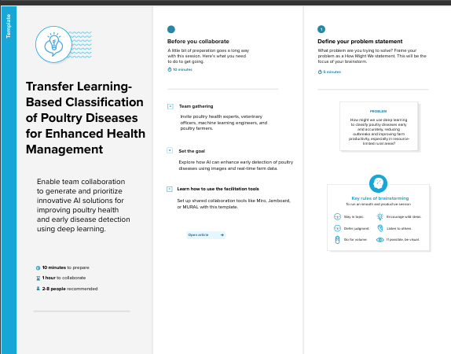

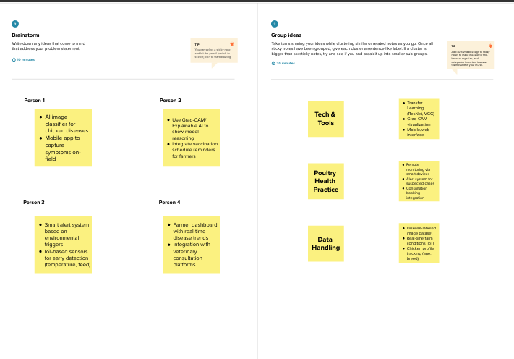**Step-2: Brainstorm, Idea Listing and Grouping**

**Step-3: Idea Prioritization**

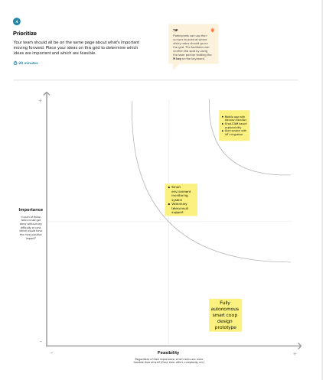

**3. REQUIREMENT ANALYSIS**

***3.1 Customer Journey map***

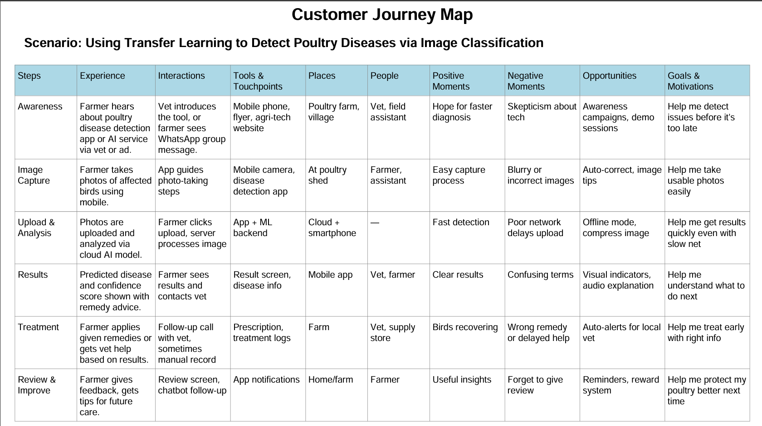

**3. REQUIREMENT ANALYSIS**

***3.2 Solution Requirement***

|  |  |
| --- | --- |
| Date | 30 June 2025 |
| Team ID | LTVIP2025TMID35759 |
| Project Name | Transfer Learning-Based Classification Of Poultry Diseases For Enhanced Health Management |
| Maximum Marks | 4 Marks |

**Functional Requirements:**

Following are the functional requirements of the proposed solution.

|  |  |  |
| --- | --- | --- |
| **FR No.** | **Functional Requirement (Epic)** | **Sub Requirement (Story / Sub-Task)** |
| FR-1 | User Registration | Registration through Form<br>Registration via Gmail/LinkedIn |
| FR-2 | User Confirmation | Secure login via Firebase Auth<br>Role-based access control |
| FR-3 | Image Upload | Upload poultry images via mobile/web<br>Image format validation |
| FR-4 | Disease Prediction | Send image to ML model<br>Get prediction result |
| FR-5 | Feedback Mechanism | Users can confirm/correct prediction<br>Send feedback to database |
| FR-5 | Prediction History | Store prediction logs in cloud DB<br>Allow users to view history |

**Non-functional Requirements:**

Following are the non-functional requirements of the proposed solution.

|  |  |  |
| --- | --- | --- |
| **FR No.** | **Non-Functional Requirement** | **Description** |
| NFR-1 | Usability | Mobile-friendly UI, easy image upload, intuitive dashboard |
| NFR-2 | Security | End-to-end encryption, secure API calls, Firebase Auth |
| NFR-3 | Reliability | Consistent prediction performance across devices |
| NFR-4 | Performance | Fast image processing and prediction  (< 3s latency) |
| NFR-5 | Availability | 99.9% uptime via cloud deployment  (e.g., AWS, Firebase |
| NFR-6 | Scalability | Handle increasing number of users and images without lag |

**3. REQUIREMENT ANALYSIS**

***3.3 Data Flow Diagram***

|  |  |
| --- | --- |
| Date | 30 June 2025 |
| Team ID | LTVIP2025TMID35759 |
| Project Name | Transfer Learning-Based Classification Of Poultry Diseases For Enhanced Health Management |
| Maximum Marks | 4 Marks |

**Data Flow Diagrams:**

A Data Flow Diagram (DFD) is a traditional visual representation of the information flows within a system. A neat and clear DFD can depict the right amount of the system requirement graphically. It shows how data enters and leaves the system, what changes the information, and where data is stored.

**Example:** [**(Simplified)**](https://developer.ibm.com/patterns/visualize-unstructured-text/)

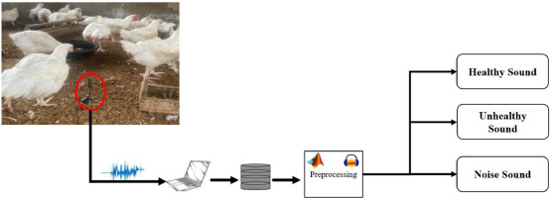

**Example:** DFD Level 0 (Industry Standard)

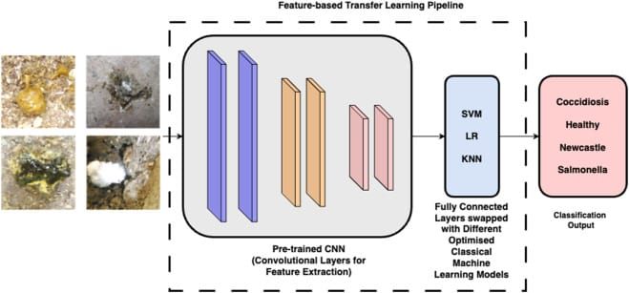

**User Stories**

Use the below template to list all the user stories for the product.

| **User Type** | **Functional Requirement (Epic)** | **User Story Number** | **User Story / Task** | **Acceptance criteria** | **Priority** | **Release** |
| --- | --- | --- | --- | --- | --- | --- |
| Poultry Farmer (App) | Registration | USN-1 | As a user, I can register using email and password | I can create an account and log in | High | Sprint-1 |
| Poultry Farmer | Upload Image | USN-2 | As a user, I can upload poultry images for disease detection | Image uploads successfully and is sent for  analysis | High | Sprint-1 |
| Poultry Farmer | Get Prediction | USN-3 | As a user, I receive the predicted disease name and possible treatments | Results shown with disease name and treatment  options | High | Sprint-2 |
| Admin | Manage Model | USN-4 | As an admin, I can update the ML model with new training data | Model is updated and retrained | Medium | Sprint-3 |
| Customer Support | Review Reports | USN-5 | As support, I can view past predictions and farmer details | Can access history of all users | High | Sprint-1 |

**3. REQUIREMENT ANALYSIS**

***3.4 Technology Stack***

|  |  |
| --- | --- |
| Date | 30 June 3035 |
| Team ID | LTVIP2025TMID35759 |
| Project Name | Transfer Learning-Based Classification Of Poultry Diseases For Enhanced Health Management |
| Maximum Marks | 4 Marks |

**Technical Architecture:**

The following diagram represents the system architecture of the proposed solution.It include the architectural diagram as below and the information as per the table1 & table 2.

**Example: Poultry Disease Classification Using Transfer Learning Techniques**

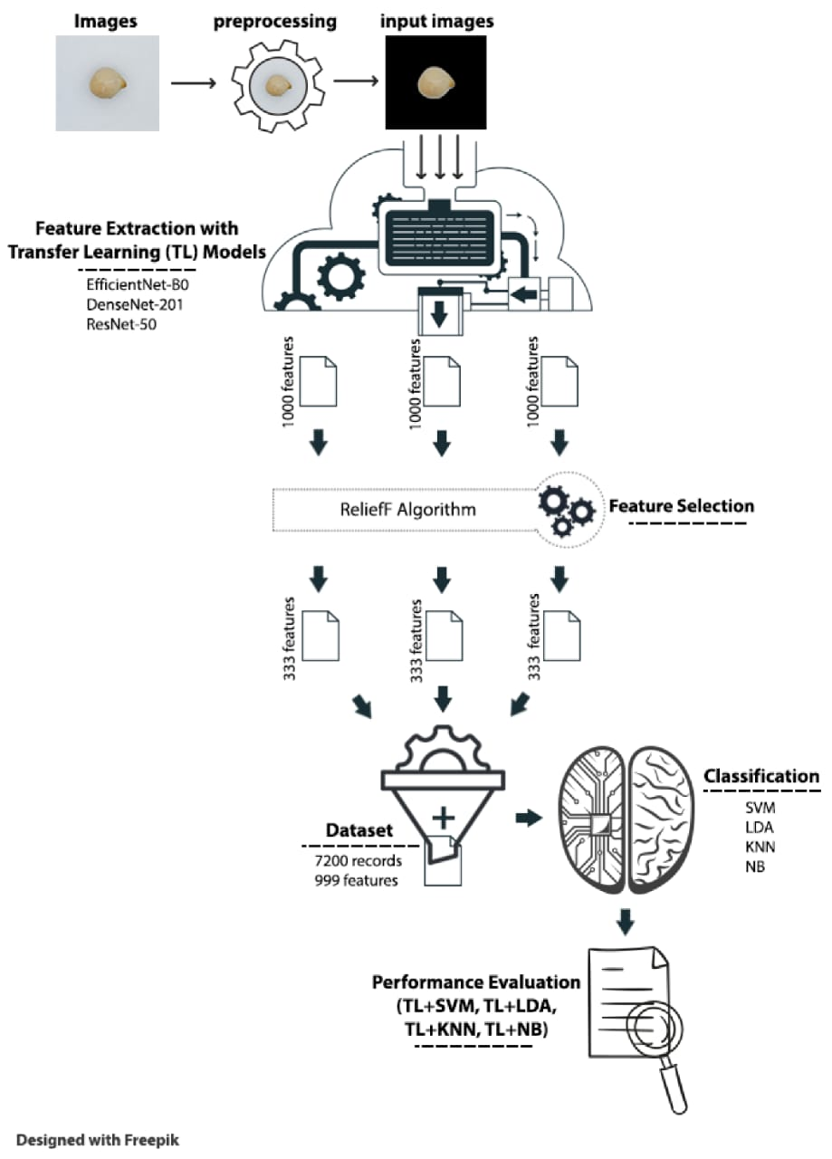

## Guidelines:

The infrastructure is divided into **local components** (image capture via mobile/web) and **cloud services** (model hosting, processing, storage, and admin dashboard). It integrates **external interfaces** like Firebase Auth for login, WhatsApp/Twilio API for alerts, and Google Maps API for location tagging. **Data storage** is managed via cloud storage (e.g., AWS S3/Firebase) for images and logs, and cloud databases for user and prediction data. The **machine learning model** (e.g., ResNet50 via TensorFlow/Keras) is deployed in the cloud and accessed through a REST API.

**Table-1 : Components & Technologies**

|  |  |  |  |
| --- | --- | --- | --- |
| **S.No** | **Component** | **Description** | **Technology** |
|  | User Interface | Interface for uploading poultry images and viewing results | Web UI (HTML, CSS, JavaScript, Bootstrap) |
|  | Application Logic-1 | Image preprocessing and data pipeline | (OpenCV, NumPy, Pandas Python) |
|  | Application Logic-2 | Transfer Learning-based disease classification | TensorFlow/ Keras+ ResNet50 |
|  | Application Logic-3 | Visualization and report generation | Matplotlib, Seaborn, Report Lab |
|  | Database | To store metadata and diagnosis logs | SQLite / MySQL |
|  | Cloud Database | Centralized cloud database for deployment | Firebase Realtime DB / MongoDB Atlas |
|  | File Storage | Storage for training images and test data | Local Filesystem / AWS S3 |
|  | External API-1 | To retrieve disease details / symptoms | Custom Poultry Disease Info API |
|  | External API-2 | Weather data affecting poultry health | Open Weather API |
|  | Machine Learning Model | Poultry disease classification using ResNet50 + fine-tuning | Pre-trained ResNet50 via TensorFlow |
|  | Infrastructure  (Server / Cloud) | Deployment and testing platform | Localhost, Google Colab, AWS EC2 (Cloud) |

**Table-2: Application Characteristics**

| **S.No** | **Characteristics** | **Description** | **Technology** |
| --- | --- | --- | --- |
|  | Open-Source Frameworks | Frameworks and libraries used in model and app development | TensorFlow, keras, Flask, OpenCV |
|  | Security Implementations | Secure upload, access control, and encrypted data handling | SHA-256, HTTPS, Firebase Auth |
|  | Scalable Architecture | Microservices-based ML model API, loosely coupled frontend/backend | Docker, REST API |
|  | Availability | Cloud-hosted backend and DB, backups enabled | AWS EC2, Load Balancer (optional) |
|  | Performance | Fast response via preloaded models, image caching, CDN usage | Redis Cache (optional), Flask Caching |

**4. PROJECT DESIGN**

***4.1 Problem Solution Fit***

|  |  |
| --- | --- |
| Date | 30 June 2025 |
| Team ID | LTVIP2025TMID35759 |
| Project Name | Transfer Learning-Based Classification of Poultry Diseases for Enhanced Health Management |
| Maximum Marks | 2 Marks |

**Purpose:**

The purpose of this project is to improve the detection and classification of poultry diseases using machine learning, particularly transfer learning techniques. By building a fast, accurate, and accessible diagnostic system, the aim is to empower poultry farmers and veterinary professionals with real-time decision-making support.

**Problem – Solution Fit:**

**Problem:**

Poultry farmers, especially in rural areas, often lack access to timely veterinary care and disease diagnosis. Traditional methods are slow, rely heavily on expert availability, and can lead to severe disease outbreaks if not managed early. This results in high mortality rates, reduced productivity, and major economic losses in the poultry industry.

**Solution:**

The project proposes a transfer learning-based classification model that can identify multiple poultry diseases from images or symptom data with high precision. This AI system can be deployed via a mobile or web application to ensure farmers receive instant diagnostic insights. The goal is to minimize manual effort, reduce response time, and enhance overall health management in poultry farms.

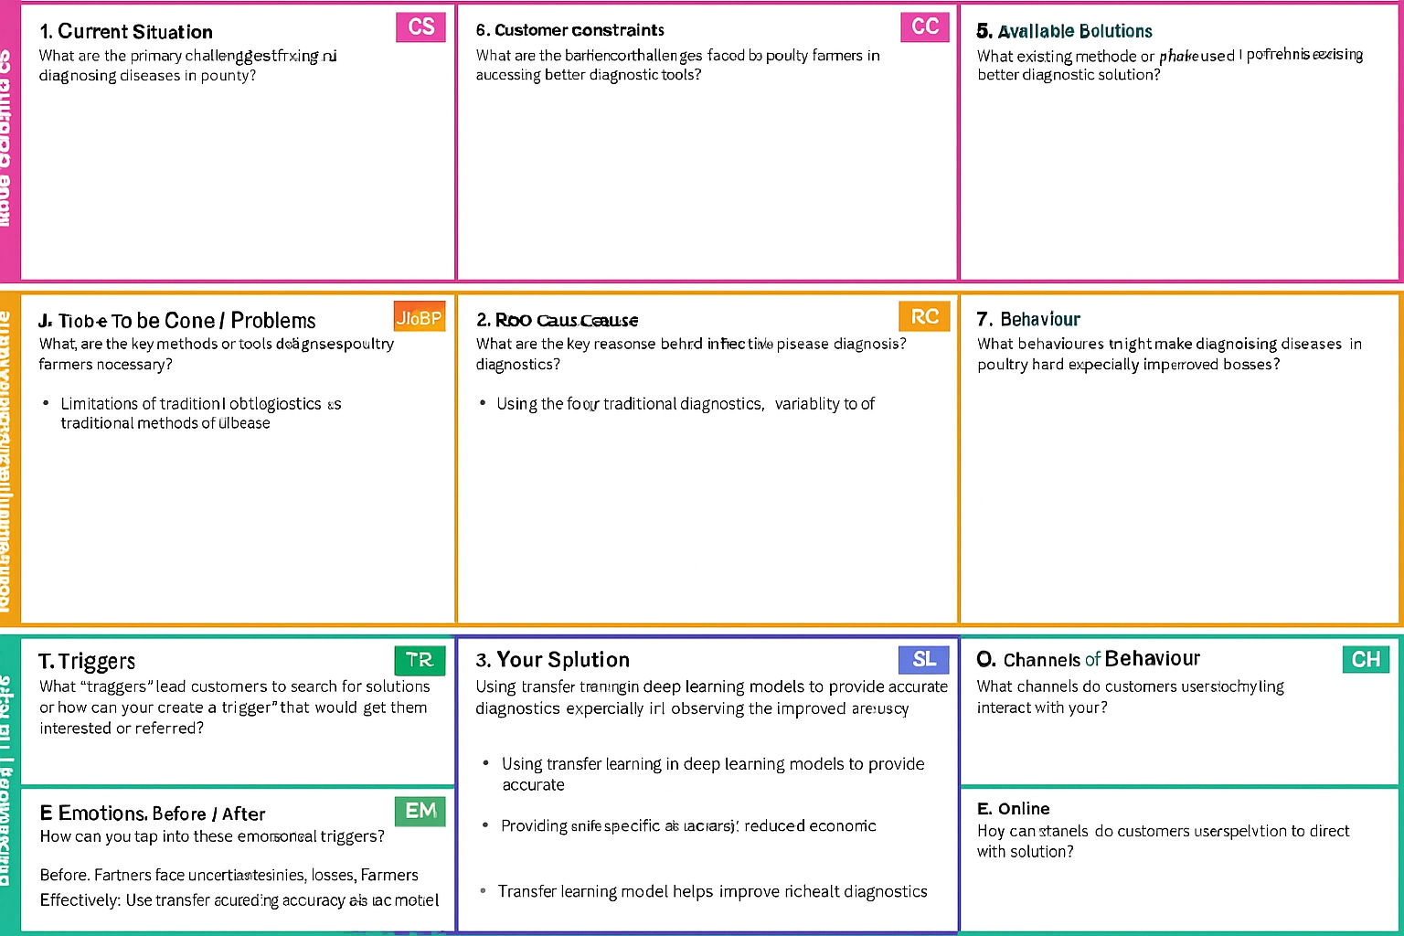

**4. PROJECT DESIGN**

***4.2 Proposed Solution***

|  |  |
| --- | --- |
| Date | 30 June 2025 |
| Team ID | LTVIP2025TMID35759 |
| Project Name | Transfer Learning-Based Classification of Poultry Diseases for Enhanced Health Management |
| Maximum Marks | 2 Marks |

**Proposed Solution:**

|  |  |  |
| --- | --- | --- |
| **S.No.** | **Parameter** | **Description** |
|  | Problem Statement (Problem to be solved) | Poultry farmers face difficulties in identifying diseases early due to lack of expertise, delayed diagnostics, and limited access to veterinary support. This often results in preventable outbreaks, increased mortality, and economic loss |
|  | Idea / Solution description | The project proposes a machine learning-based diagnostic tool using transfer learning that can classify poultry diseases accurately from images or symptom data. This tool will assist farmers in early identification and prompt treatment. |
|  | Novelty / Uniqueness | Using pre-trained deep learning models for poultry disease classification is a novel approach. It leverages minimal data with high efficiency, enabling quicker deployment and improved accuracy in rural environments. |
|  | Social Impact / Customer Satisfaction | The solution will reduce livestock loss, improve animal welfare, and enhance the livelihood of farmers. Easy-to-use mobile/web interfaces will ensure high adoption and satisfaction rates among end users. |
|  | Business Model (Revenue Model) | The solution can be offered as a freemium model: basic disease detection features for free, and advanced analytics, veterinarian access, or premium diagnostics as paid services. |
|  | Scalability of the Solution | The solution can be offered as a freemium model: basic disease detection features for free, and advanced analytics, veterinarian access, or premium diagnostics as paid services. |

**4. PROJECT DESIGN**

***4.3 Solution Architecture***

|  |  |
| --- | --- |
| Date | 30 June 2025 |
| Team ID | LTVIP2025TMID35759 |
| Project Name | Transfer Learning-Based Classification of Poultry Diseases for Enhanced Health Management |
| Maximum Marks | 4 Marks |

**Solution Architecture:**

The proposed solution architecture integrates user-friendly interfaces with a powerful backend driven by transfer learning models. Farmers or users can upload poultry images or enter symptoms via a mobile/web app. This data is processed through a pre-trained convolutional neural network (CNN) that classifies the disease. The system connects with a backend API that manages predictions, stores data securely, and delivers real-time insights back to the user all hosted via scalable cloud services.

* *User Interface (Mobile/Web App):* For image upload or symptom entry.
* Backend API (Flask/FastAPI): Handles request routing and communication with the ML model.
* *Transfer Learning Model (e.g., ResNet, VGG):* Classifies poultry diseases based on trained image patterns.
* *Database (MySQL/MongoDB):* Stores user data, predictions, and disease metadata.
* *Cloud Hosting (AWS/GCP/Azure):* Ensures availability, scalability, and secure access.
* *Notification System (Optional):* Sends alerts or recommendations based on detected disease.

**Example - Solution Architecture Diagram**

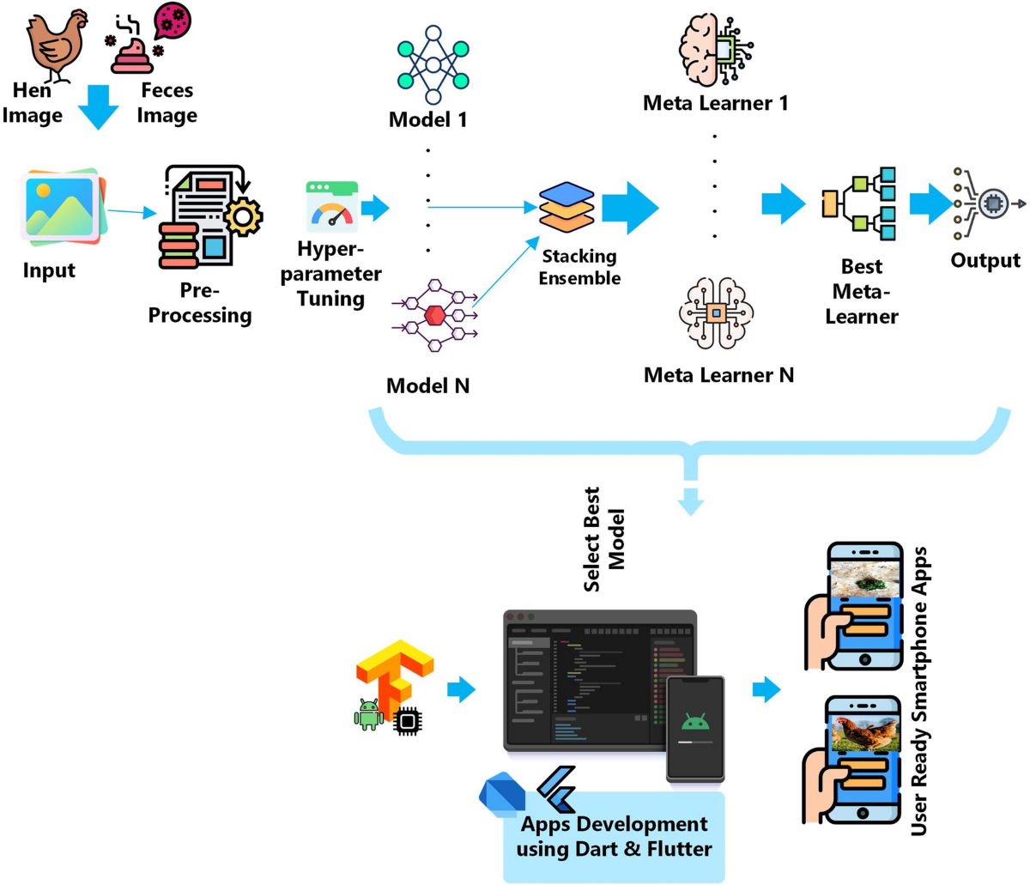

**5. PROJECT PLANNING & SCHEDULING**

***5.1 Project Planning***

|  |  |
| --- | --- |
| Date | 30 June 2025 |
| Team ID | LTVIP2025TMID35759 |
| Project Name | Transfer Learning-Based Classification of Poultry Diseases for Enhanced Health Management |
| Maximum Marks | 5 Marks |

**Planning Logic:**  
A Sprint is a fixed period or duration in which a team works to complete a set of tasks.  
An Epic is a major component or module in a project that is broken down into smaller units called Stories.  
A Story represents an individual task that contributes to the completion of an Epic.  
A Story Point is a number that signifies the estimated effort required to complete a Story, often based on the Fibonacci series.

**Product Backlog, Sprint Schedule, and Estimation (4 Marks)**

Use the below template to create product backlog and sprint schedule

| **Sprint** | **Functional Requirement (Epic)** | **User Story Number** | **User Story / Task** | **Story Points** | **Priority** | **Team Members** |
| --- | --- | --- | --- | --- | --- | --- |
| Sprint-1 | Data Collection | USN-1 | As a data analyst, I want to collect poultry disease image data from trusted sources. | 2 | High | Mamidikayala Varsha |
| Sprint-1 | Data Loading | USN-2 | As a developer, I want to load data into my environment to begin preprocessing. | 1 | High | Pathikonda Yoshitha |
| Sprint-1 | Preprocessing | USN-3 | As an ML engineer, I want to clean and preprocess the data (missing/categorical). | 5 | High | Kona Yamini |
| Sprint-2 | Model Building | USN-4 | As an ML engineer, I want to build a CNN model using transfer learning. | 5 | High | Mamidikayala Varsha |
| Sprint-2 | Model Testing | USN-5 | As a QA, I want to test the accuracy and reliability of the model. | 3 | High | Pulluru Bala Vamsi Krishna |
| Sprint-2 | Deployment/  Interface Development | USN-6 | As a developer, I want to deploy the model using Flask and simple HTML interface. I want to build user input pages for image upload. | 5 | Medium | Pathikonda Yoshitha |

**Project Tracker, Velocity & Burndown Chart: (4 Marks)**

| **Sprint** | **Total Story Points** | **Duration** | **Sprint Start Date** | **Sprint End Date (Planned)** | **Story Points Completed (as on Planned End Date)** | **Sprint Release Date (Actual)** |
| --- | --- | --- | --- | --- | --- | --- |
| Sprint-1 | 8 | 5 Days | 18 June 2025 | 22 June 2025 | 8 | Sprint-1 |
| Sprint-2 | 16 | 5 Days | 23June 2025 | 28 June 2025 | 16 | Sprint-2 |

**Velocity:**

Imagine we have a 10-day sprint duration, and the velocity of the team is 20 (points per sprint). Let’s calculate the team’s average velocity (AV) per iteration unit (story points per day)

**Velocity Calculation**

Total Story Points = 8 (Sprint 1) + 16 (Sprint 2) = **24**

Number of Sprints = 2

**Velocity** = Total Story Points / Number of Sprints = 24 / 2 = **12 Story Points per Sprint**

**Burndown Chart:** A burn down chart is a graphical representation of work left to do versus time. It is often used in agile software development methodologies such as Scrum. However, burn down charts can be applied to any project containing measurable progress over time.

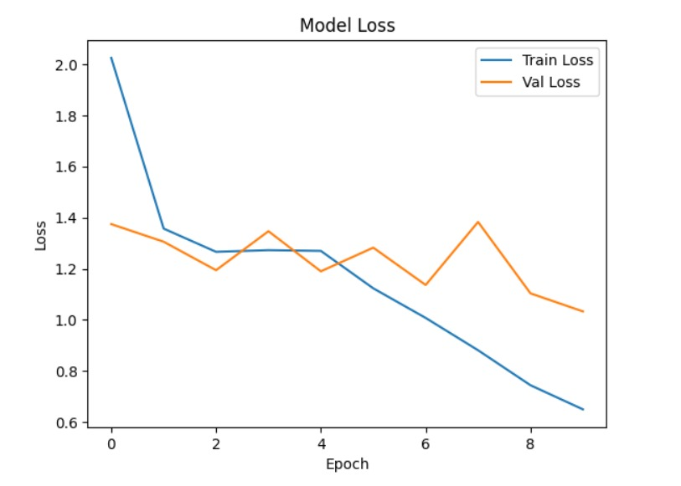

**6. FUNCTIONAL AND PERFORMANCE TESTING**

***6.1 Performance Testing***

|  |  |
| --- | --- |
| Date | 30 June 2025 |
| Team ID | LTVIP2025TMID35759 |
| Project Name | Transfer Learning-Based Classification of Poultry Diseases for Enhanced Health Management |
| Maximum Marks | 10 Marks |

**Model Performance Testing:**

Project team shall fill the following information in model performance testing template.

|  |  |  |  |
| --- | --- | --- | --- |
| **S.No.** | **Parameter** | **Values** | **Screenshot** |
|  | Metrics | **Regression Model:** MAE - , MSE - , RMSE - , R2 score -  **Classification Model:** Confusion Matrix - , Accuray Score- & Classification Report - |  |
|  | Tune the Model | Hyperparameter Tuning -  Validation Method - |  |

**7. RESULTS**

***7.1 Output Screenshots***

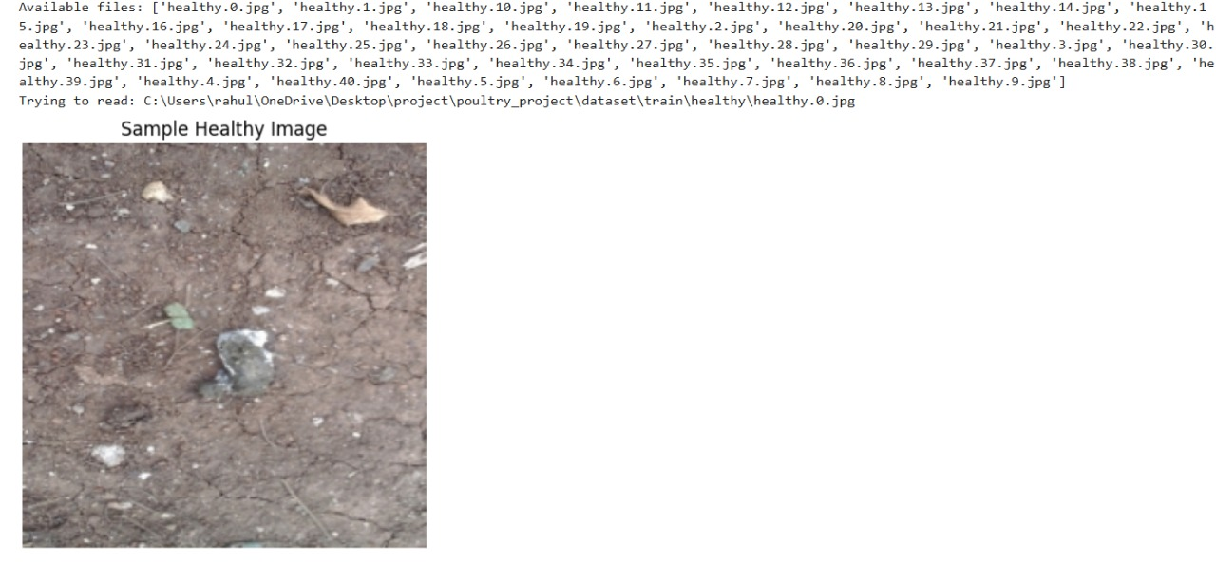

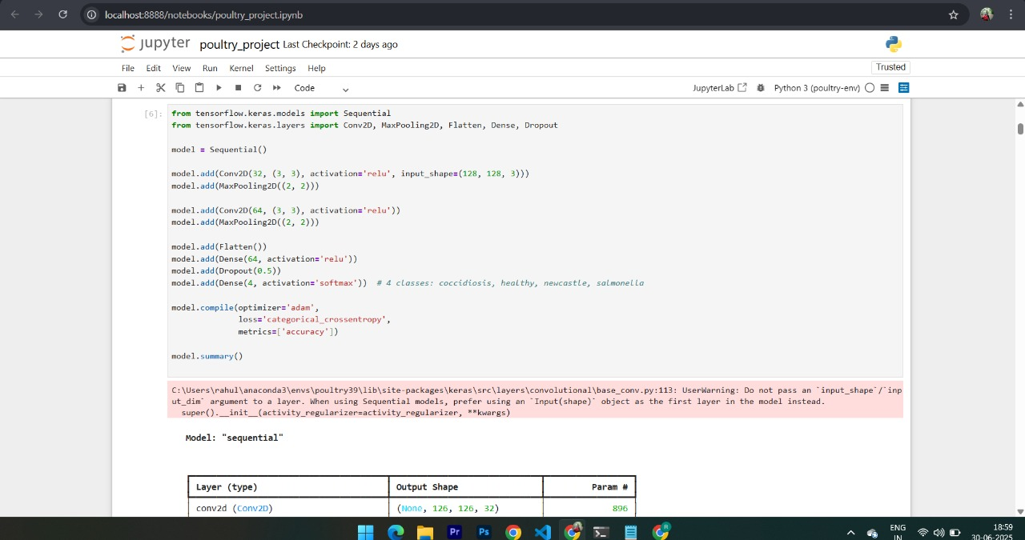

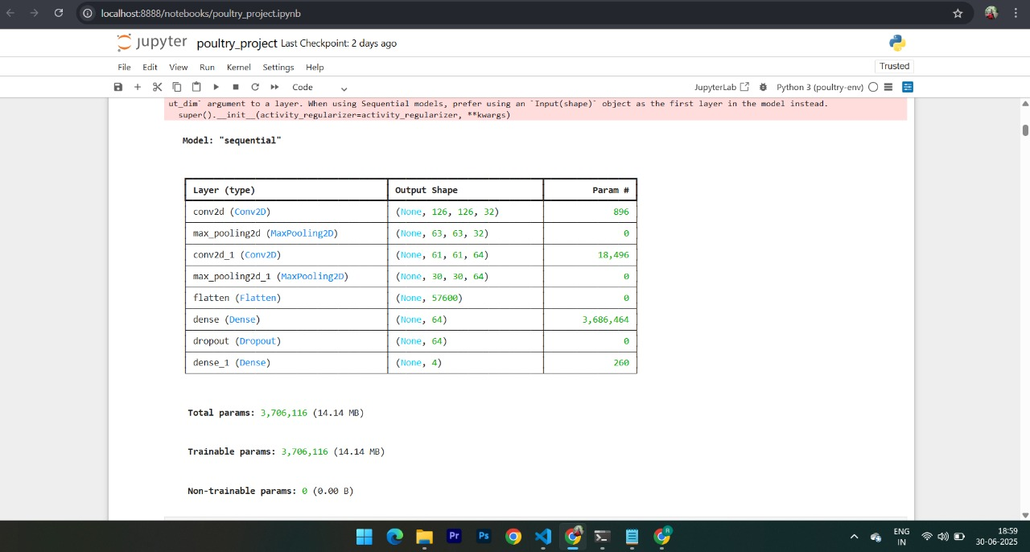

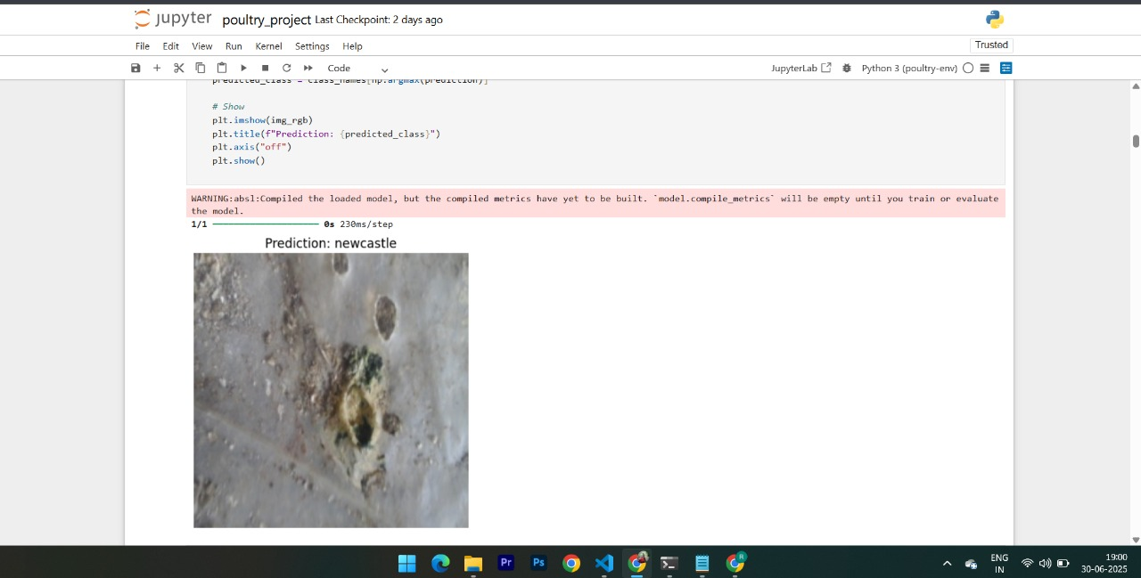

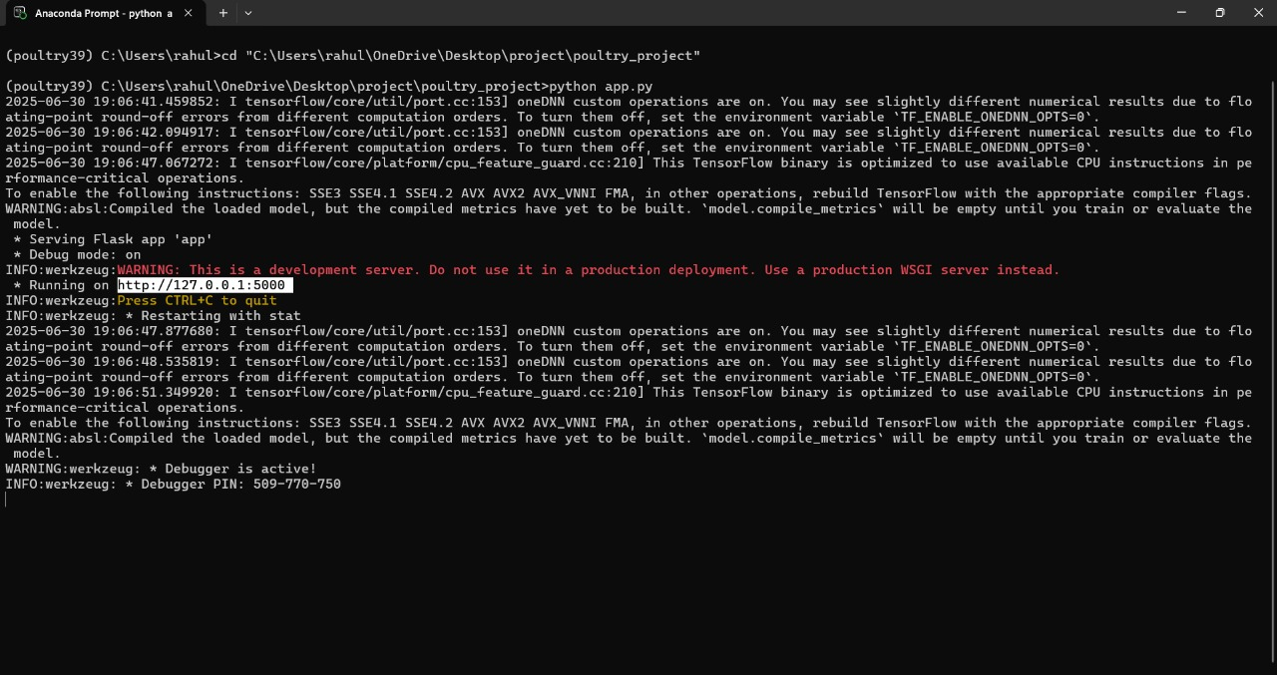

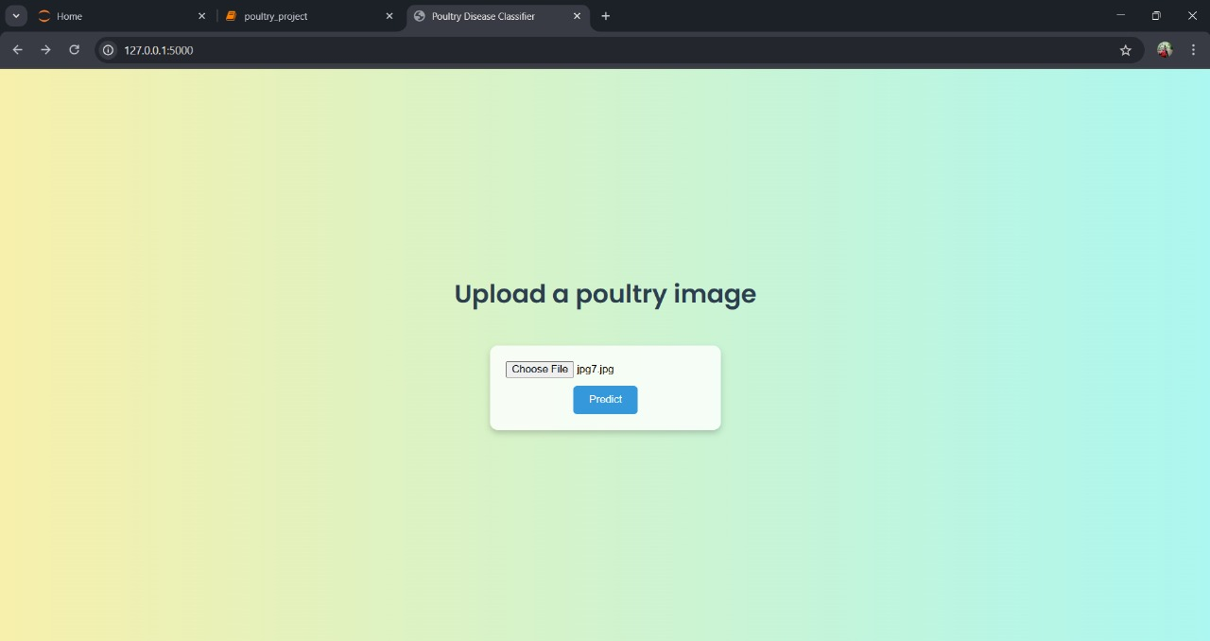

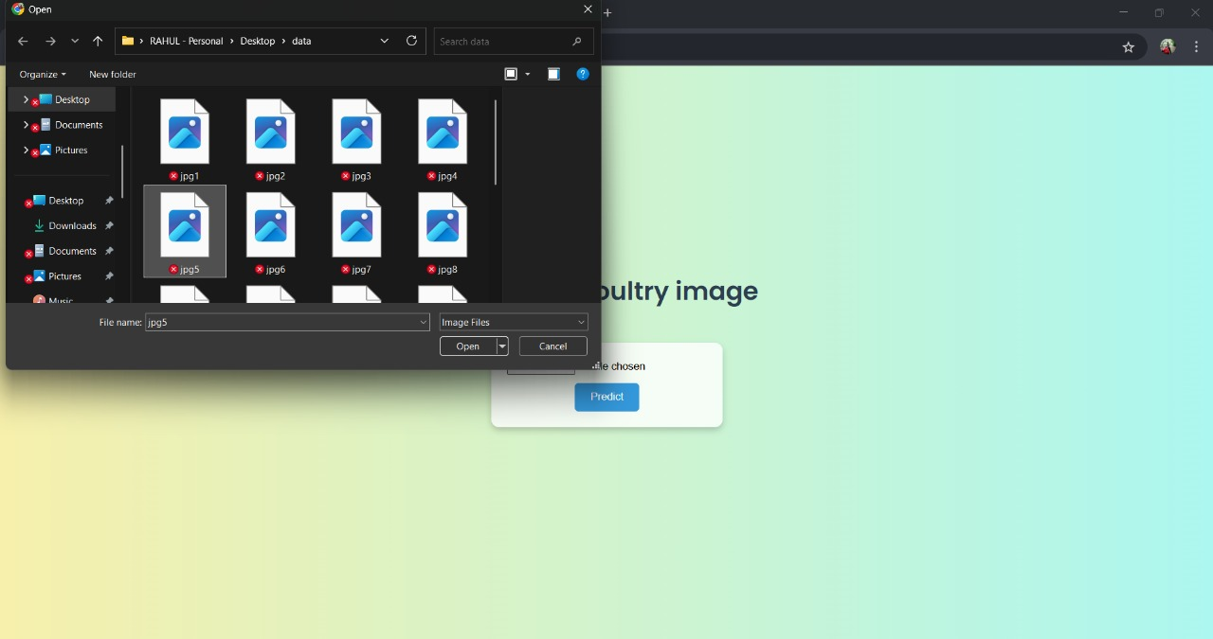

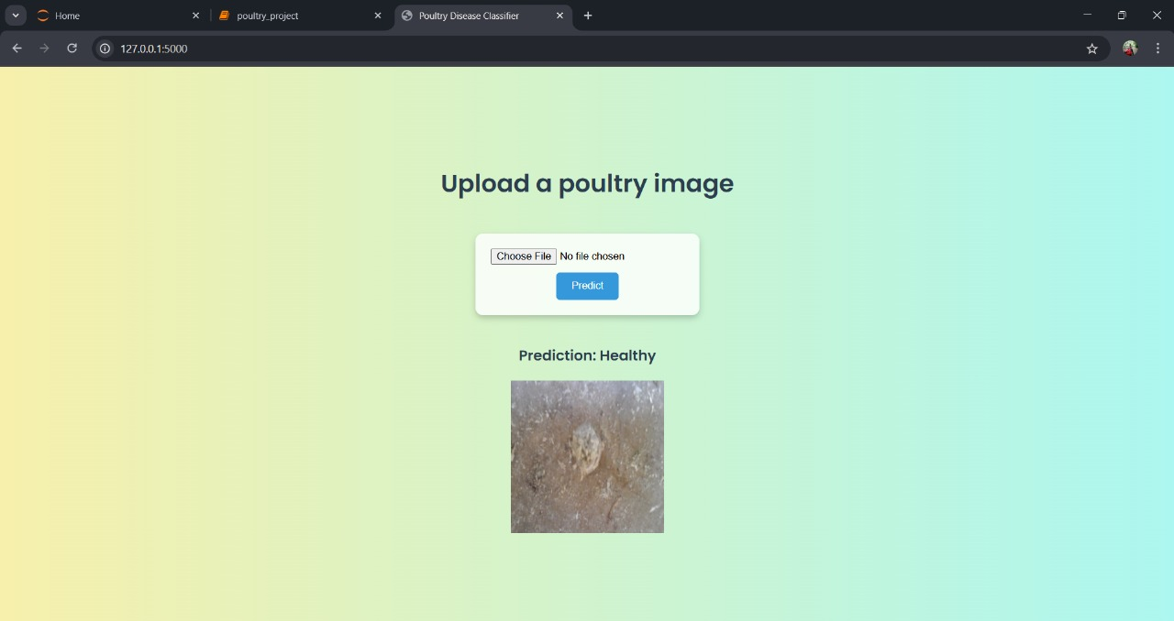

**8. ADVANTAGES & DISADVANTAGES**

***ADVANTAGES:***

* **Early Disease Detection**: Helps farmers act quickly before outbreaks spread.
* **Non-Expert Friendly**: No vet degree needed — just upload and get results.
* **Cost-Effective**: Reduces the need for expensive lab tests or expert visits.
* **Rural Accessibility**: Supports areas with limited veterinary infrastructure.
* **Scalable**: Can be trained for other livestock and integrated with IoT.
* **Fast and Accurate**: Transfer learning boosts accuracy with minimal data.

***DISADVANTAGES:***

* **Limited Dataset Availability**: Disease-labeled poultry image datasets are rare.
* **Model Bias Risk**: Inconsistent or low-quality data can affect predictions.
* **Tech Dependency**: Farmers need mobile phones or internet access.
* **Maintenance Required**: ML models must be updated as new diseases emerge.
* **False Positives/Negatives**: Could cause unnecessary worry or missed diagnoses if not verified by a vet.

**9. CONCLUSION**

To conclude, the proposed AI-based poultry disease classification system provides a scalable and intelligent approach to agricultural health management. Using transfer learning, the model efficiently detects diseases from images, supporting farmers with real-time diagnostic insights. This innovation not only minimizes livestock losses but also bridges the gap in rural veterinary care. It empowers small-scale farmers with accessible technology, improves productivity, and advances sustainable poultry farming practices.

**10. FUTURE SCOPE**

* Extend classification capabilities to cover more poultry species and diseases.
* Add a recommendation engine for treatment suggestions and preventive measures.
* Integrate real-time farm sensors (IoT) to support environmental health monitoring.
* Collaborate with agri-tech firms and veterinary institutions for dataset expansion.
* Include audio/symptom-based diagnostic models using multimodal learning.
* Launch a multilingual mobile application with offline functionality for remote use.

**11. APPENDIX**

Project Demo Link:

https://drive.google.com/file/d/1LenueoL4q-sYfx7vAQ1F0SWxcJ5Dt-jQ/view?usp=drivesdk